EE 214

ELECTRONICS

Spring 2000-01

MIDTERM EXAM I

April 10, 2001 9:00 Duration: 100 dakika

IMPORTANT: READ BEFORE STARTING

- There are four questions, attempt all.
- Use the reserved space to answer each question. Written material outside the reserved space will not be considered for credit.
- Show complete work for full credit.
- Include units in your answers.
- You have more than sufficient time to answer the questions. Read the questions carefully, organize your work and write legibly.
- If you are asked to DERIVE an expression, you must DERIVE it starting from the basic laws and showing your complete work in order to get credit.
GOOD LUCK

Surname :

Name :

Student No :

Question | Points | Score
1 | 25
2 | 25
3 | 25
4 | 25
TOTAL | 100

Useful Material

Boltzmann’s constant k = 1.38x10⁻²³ J/K
= 8.62x10⁻⁵ eV/K

Electronic charge q = 1.6x10⁻¹⁹ C

Room temperature value of kT = 0.0259eV

1 eV = 1. 6x10⁻¹⁹ J

n_{i} = 10¹⁰ cm⁻³ at 300K

Planck’s constant h=6.626x10⁻³⁴ Jsec

Velocity of light c=3x10⁸ m/sec

Semiconductor | E_{g}(eV)
Carbon | 5.47
Silicon | 1.12
Germanium | 0.66
Gallium Arsenide | 1.42

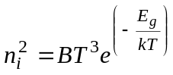

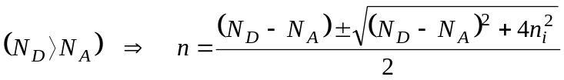

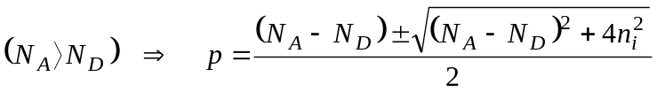

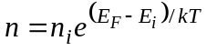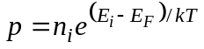

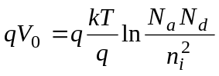

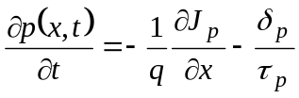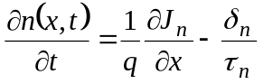
Q.1.
- (4 points) If n_{i}=10¹⁰cm⁻³ for Si at T=300K, calculate intrinsic carrier concentration for Si at T=400K.
Answer:

- (5 points) Calculate electron and hole concentration for a Si semiconductor doped with N_{D}=10¹⁰cm⁻³ at T=300K. Is this an n-type, a p-type or an intrinsic semiconductor material? Explain your reasoning.
Answer:

- (5 points) Without any calculation, estimate n and p for Si at T=400K doped with N_{D}=10¹⁰cm⁻³. Is this an n-type, a p-type or an intrinsic material? Explain your reasoning.
Answer:

Q.1. continued
- (7 points) If μ_{n}=0.135m²/Vsec for Si at 300K and does not change with N_{D}, calculate N_{D} that is required to achieve a drift current density of j_{drift}=100mA/cm² under an electric field of E=1V/cm. (You may assume that μ_{n}n>> μ_{p}p and n is approximately equal to N_{D} ).
Answer:

- (4 points) If in part (d) μ_{n} were not constant, but instead had a non-linear dependency N_{D}, describe qualitatively how would you solve for N_{D}.
Answer:
Q.2.
A p-n junction is formed by a p-type Si with N_{A}=5x10¹⁷cm⁻³ and an n-type Si with N_{D}=10¹⁶cm⁻³ , at 300ºK.

- (5 points) Calculate the Fermi level positions with respect to E_{i} at 300ºK in the p-type and n-type regions.
Answer:

- (20 points) Sketch the electrostatic potential, the built in electric field, the energy band diagram, and the particle flow and the current into the corresponding boxes provided on the next page when the junction is zero biased, forward biased and reverse biased. When showing the particle flow and current select an arrow from the set of arrows:
1

2

3

4

5

6

to represent the direction and the magnitude of flow and write down the corresponding number into the space provided.

Q.2. continued

Zero Bias Forward Bias Reverse Bias
Electrostatic
Potential
Particle Flow
Current
Particle Flow
Current
Particle Flow
Current
Energy band
Diagram
Built-in
Elect. Field
Hole Diffusion

Hole Drift

Electron
Diffusion

Electron
Drift

Electric
Field

Q.3.
Excess holes are injected into an n-type semi-infinite semiconductor bar at x=0 continuously as shown below (injection occurs only at x=0). Hole injection maintains a constant steady-state excess hole concentration of 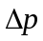 at x=0. This is a low level injection and the electric field inside the semiconductor is zero everywhere. Hole recombination lifetime in the semiconductor is 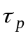 and the diffusion coefficient for the holes is D_{p}.
x
Excess hole injection
x=0

a.) (12 points) Modify the continuity equation for this problem and derive the expression for the steady-state excess hole concentration, 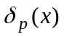, for x>0 ın terms of the dıffusıon length of holes by showıng your comlete work. Sketch a plot of versus x.

Q.3. continued
a.) (13 points) Now assume that the length of the semiconductor bar is w. The excess minority carrier concentrations at the ohmic contact is zero. Derive the expression for the steady-state excess hole concentration, , for x>0 in terms of the diffusion length of holes by showing your comlete work. Sketch a plot of versus x.

x=w
x
Excess hole injection
x=0
Ohmic contact

Q.4.
a.) (7 points) Draw the output voltage waveform (v_{o}) of the following circuit in response to the given input waveform (v_{s}). Assume that the diode and the capacitor are ideal. Initial (at t = 0) capacitor voltage is equal to zero. Note that the source is switched ON at time t=0.
-10V
-5V
5V
-5V
5V
v_{o}
t
t
v_{s}
-
+
C
+
v_{s}
v_{o}
-

b.) (8 points) Draw the output voltage waveform for the following circuit to the space provided, when the input signal is equal to v_{i} = V_{p}sinωt . Assume that the diodes and the capacitors are ideal. Initial (at t = 0) voltages on both capacitors are equal to zero. Note that the source is switched ON at time t=0.

v_{o}
v_{i}
C2
C1
D2
D1
+
+
+
v_{i}
-
+
v_{o}

Q.4. continued

c.) (10 points) We would like to manufacture a photo-diode which will be sensitive to light with a wavelenght of 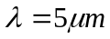. List the suitable semiconductor materials for this device, from the table given below.

Semiconductor  Answer: (Show your reasoning) | Bandgap energy (eV)
Ge | 0.66
GaAs | 1.43
InSb | 0.22
Si | 1.12
InP | 1.35

Draw a circuit, into the space provided below, to use this photo-diode as a photo-detector. You are allowed to use a supply voltage of 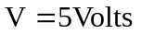and a resistor. The diode current is equal to 100μAmps, under illumination. The dark current of the diode is equal to 10μAmps.
Mark the terminals between which you would measure the output voltage.
What should be the resistor value to obtain output voltage of 2Volts under illumination?
Find the output voltage with no illumination, by using the calculated resistor value.
Calculate resistor value here:

R=
Draw the circuit here:

Calculate no illumination output voltage here:

V_{o}=

